**EXPERIMENT 1A**

**PROGRAM:**

**.html:**

<!DOCTYPE HTML PUBLIC "-//W3C//DTD HTML 4.01 Transitional//EN">

<html>

<head>

<title>Exp6A</title>

</head>

<body>

<h3 align="center">Fading Channels and Mobile Communication</h3>

<h4 align="center">Virtual Lab-IIT Kharagpur</h4>

<h3 align="center">Experiment 1A: Frequency Reuse(Co-channel Cells)</h3>

<script src="deployJava.js"></script>

<p align="center">

<script>

var attributes = {

code: "exp6.exp6B",

archive: "Exp6.jar, lib/iText-2.1.5.jar, lib/jcommon-1.0.16.jar, lib/jfreechart-1.0.13.jar",

width: 1210,

height: 555

};

var parameters = {jnlp_href:"Exp6A.jnlp"}; <!-- Applet Parameters -->

var version = "1.5"; <!-- Required Java Version -->

deployJava.runApplet(attributes, parameters, version);

</script>

</p>

</body>

</html>

**.jnlp:**

<?xml version="1.0" encoding="UTF-8" standalone="no"?>

<jnlp href="Exp6A.jnlp" spec="1.0+">

<information>

<title>Exp1A</title>

<vendor>IIT Kharagpur</vendor>

<homepage href=""/>

<description>Exp1</description>

<description kind="short">Exp1</description>

</information>

<update check="always"/>

<security>

<all-permissions/>

</security>

<resources>

<j2se java-vm-args="-Djava.security.policy=applet.policy" version="1.5+"/>

<jar href="Exp6.jar" main="true"/>

<jar href="lib/jfreechart-1.0.13.jar"/>

<jar href="lib/jcommon-1.0.16.jar"/>

<jar href="lib/iText-2.1.5.jar"/>

</resources>

<applet-desc height="610" main-class="exp6.exp6A" name="Exp6" width="1213">

</applet-desc>

</jnlp>

**OUTPUT:**

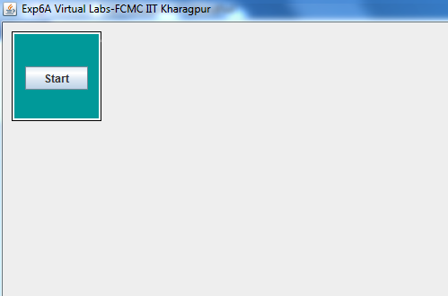

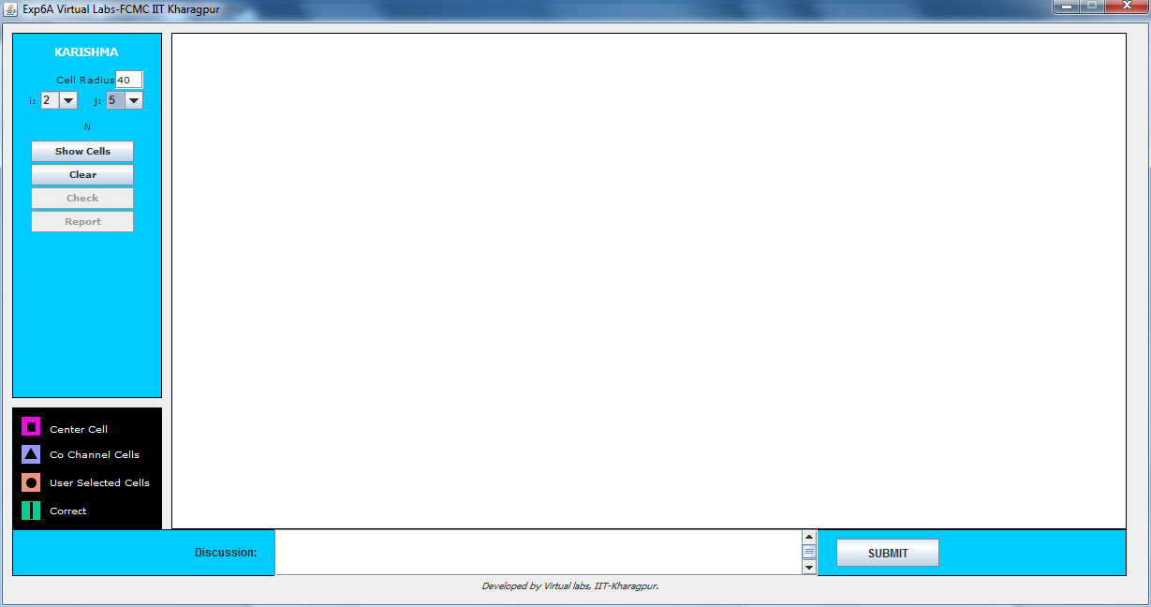

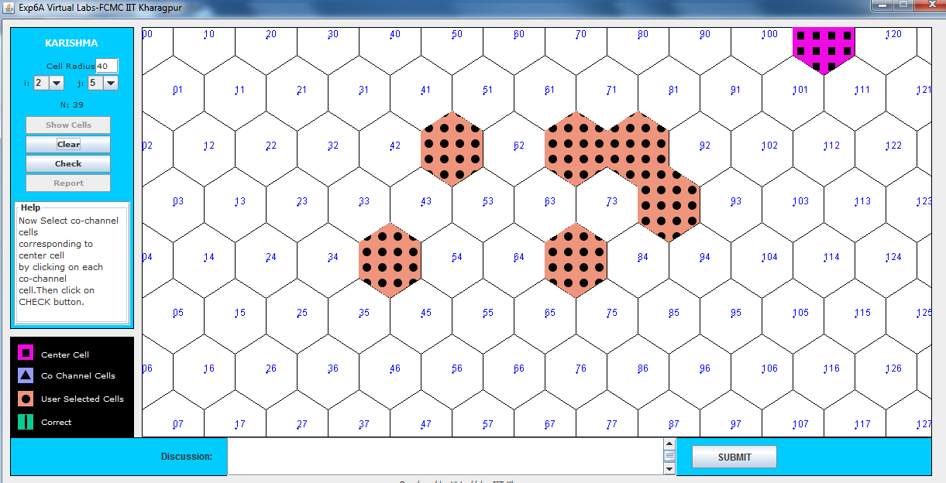

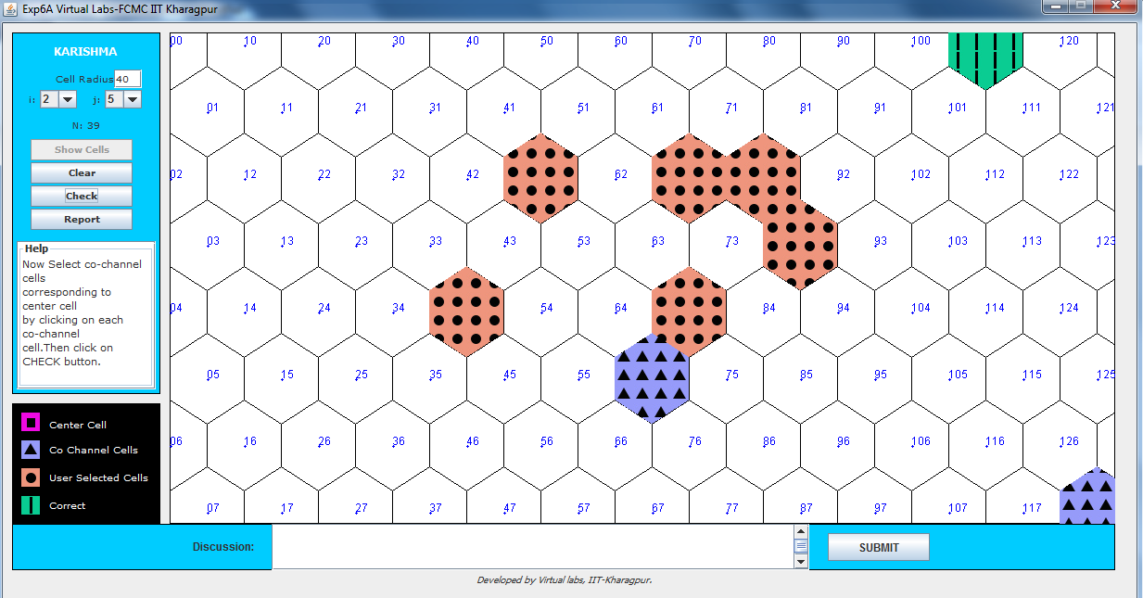

**EXPERIMENT 1B**

**PROGRAM:**

**.html:**

<!DOCTYPE HTML PUBLIC "-//W3C//DTD HTML 4.01 Transitional//EN">

<html>

<head>

<title>Exp1B</title>

</head>

<body>

<h3 align="center">Fading Channels and Mobile Communication</h3>

<h4 align="center">Virtual Lab-IIT Kharagpur</h4>

<h3 align="center">Experiment 6A: Frequency Reuse(Cell Cluster)</h3>

<script src="deployJava.js"></script>

<p align="center">

<script>

var attributes = {

code: "exp6.exp6B",

archive: "Exp6.jar, lib/iText-2.1.5.jar, lib/jcommon-1.0.16.jar, lib/jfreechart-1.0.13.jar",

width: 1210,

height: 555

};

var parameters = {jnlp_href:"Exp6B.jnlp"}; <!-- Applet Parameters -->

var version = "1.5"; <!-- Required Java Version -->

deployJava.runApplet(attributes, parameters, version);

</script>

</p>

</body>

</html>

**.jnlp:**

<?xml version="1.0" encoding="UTF-8" standalone="no"?>

<jnlp href="Exp6B.jnlp" spec="1.0+">

<information>

<title>Exp1B</title>

<vendor>IIT Kharagpur</vendor>

<homepage href=""/>

<description>Exp1</description>

<description kind="short">Exp1</description>

</information>

<update check="always"/>

<security>

<all-permissions/>

</security>

<resources>

<j2se java-vm-args="-Djava.security.policy=applet.policy" version="1.5+"/>

<jar href="Exp6.jar" main="true"/>

<jar href="lib/jfreechart-1.0.13.jar"/>

<jar href="lib/jcommon-1.0.16.jar"/>

<jar href="lib/iText-2.1.5.jar"/>

</resources>

<applet-desc height="610" main-class="exp6.exp6B" name="Exp6" width="1210">

</applet-desc>

</jnlp>

**OUTPUT:**

